**PROJECT SUMMARY ON DATA ANALYSES PERFORM ON NIGERIA’S COVID-19 DATA COLLECTED ON A GLOBAL SCALE.**

Covid-19 pandemic hit many countries hard and it affected almost all countries directly or indirectly. Be it in the economy of the country or the live of its citizen which were been lost within the hit of the virus. Panda’s analytics was been used to extract data from external data sources which were been stored by the NCDC and John Hopkins University Center FOR systems Science and Engineering.

After collecting all this data and performing proper data cleaning and analyses on it. Certain conclusion was be taken as it was observed that the state which got the most hit in Nigeria was Lagos. Factors influencing it was because of it very dense population and it also been the economic capital of the nation with an outstanding budget due to how big the economy of the state is. As a result of the pandemic, it was noticed that the budget of the country reduce in the second quarter of the year 2020, were as before the pandemic the budget usually increases directly without any obstructions

In Nigeria, Cross River state face the highest reduction of Real GDP budget when covid hit. Also, it should be noted that Lagos had the most confirmed lab cases and it recorded the most confirmed lab cases on the 2023-03-09 with a total of 6158 cases recorded.

Below are some visualizations which were derived after performing some analyses on the data provided.

**PLOT TO SHOW NUMBER OF STATE CONFIRM CASES**

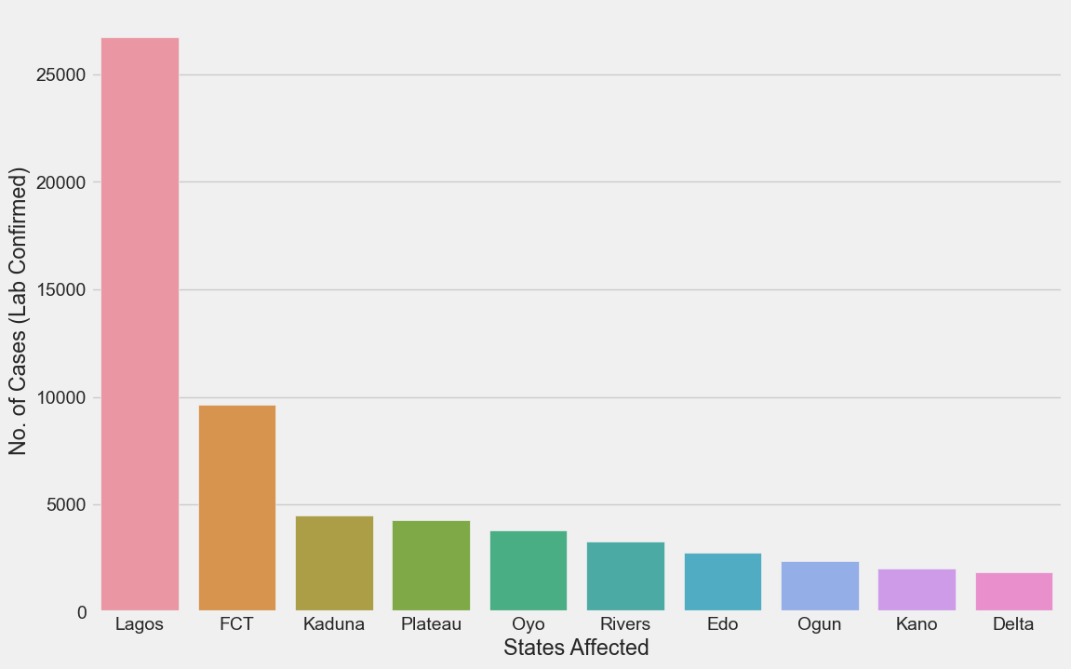

From the plot above, it can be clearly seen that Lagos state had the most lab confirmed cases with almost 26000 persons. The graph above shows the top 10 states with the most recorded covid cases in Nigeria.

**BOXPLOT OF THE NUMBER OF DISCHARGE PER STATES**

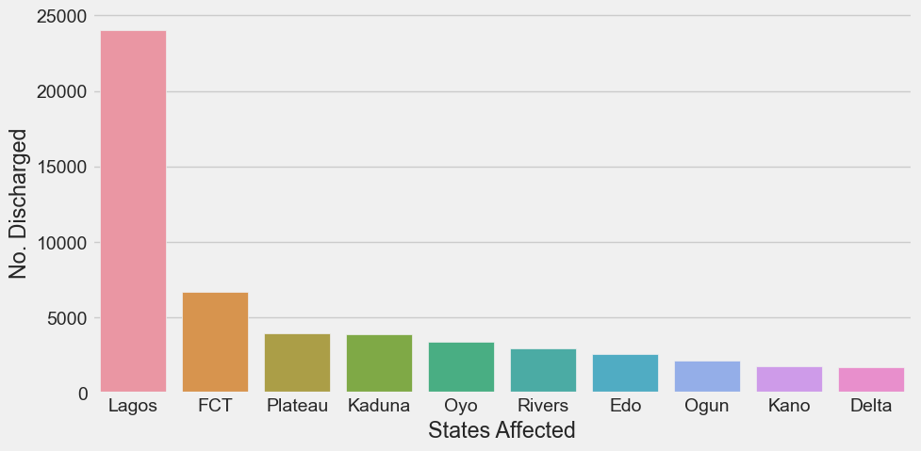

The graph above represents the number discharge recorded per state.

**GRAPH OF TOTAL DAILY DEATH CASES PER STATE**

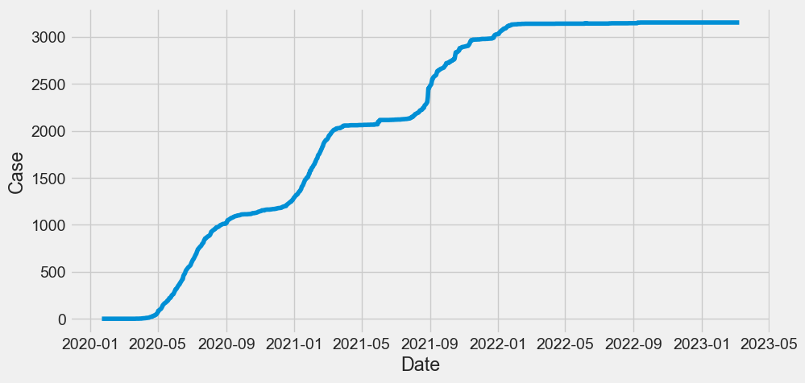

The graph shows the daily death cases recorded in each state throughout Nigeria.

**GRAPH TO SHOW THE RELATIONSHIP BETWEEN NUMBER OF CASES AND POPULATION DENSITY.**

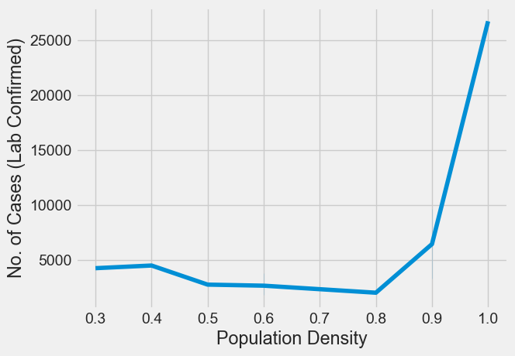

It is seen in the graph that number of cases increases as the population density is high. So state with high population density get to get more confirmed cases.

**GRAPH TO SHOW HOW COVID AFFECTED COUNTRY BUDGET**

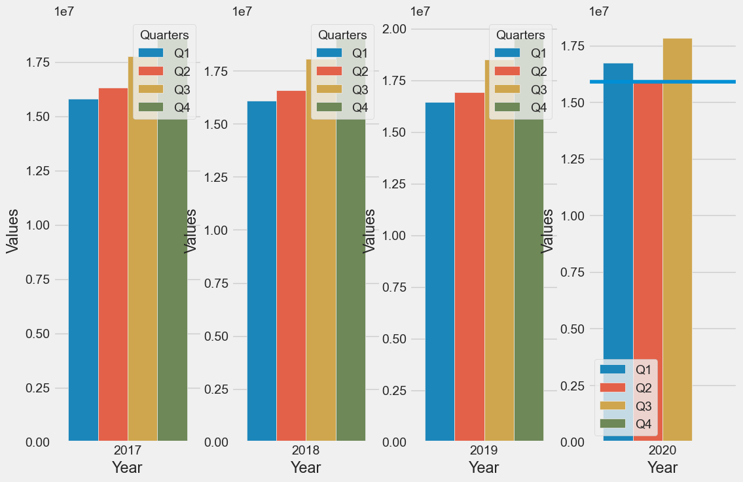

Notice that before covid 19, The state budget increase linearly as years pass by. But in the year 2020 the state budget drop sharply at the second quarter of the year.

**STAND OUT SECTION**

A graph was been plotted to see the state which had the highest number of covid admitted patients into the hospital. From this graph it was seen that FCT had the most recorded admission as compared to Lagos state which had the highest number of covid recorded confirmed cases.

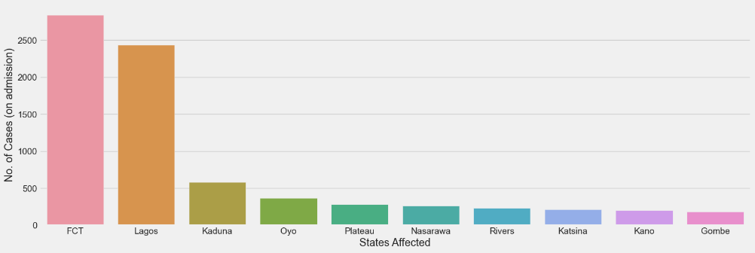

A graph of how covid affected the various states budget was been plotted to see the relationship of the economy budget before covid hit and how the budget was been reduced when covid hit.

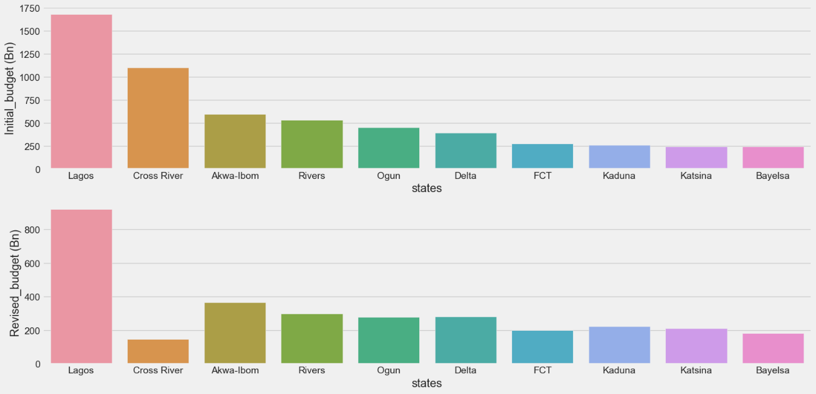

From the graph it can been seen that Cross River State had a significant deduction of state budget.